- 3 -

Our Lord cannot give to us spiritual gifts in abundance immediately or they will be misused by us, redirected to a destructive passion. The passions need to be reordered – purgation first, then illumination. (see James 4:1-3)

The more we follow the commandments and seek spiritual cleansing through Christ (purgation), the more we are able to see the depths of the wisdom in the Bible (illumination). Our souls, like a polished mirror, reflect more fully the Divine life and we can see truth more clearly.

As our souls are being illuminated by God, we are more ready to become, and in fact are becoming, united with Him in our lives –we think and want and do more and more like Jesus. There is a reorientation of our souls from the worldly (carnal) towards the love of God and our neighbour (spiritual). Our desire is stirred up by God and we become wiser about where and how to look for God. We become more prayerful. We want with all our hearts to see God – and we know the promise of Christ, blessed are the pure in heart for they shall see God (Matt. 5:8).

These three basic stages of spiritual maturity can be found, and in this order, in the Sunday readings in Trinity season.

Purgation is a stage characterized by the purging of our lives of sin, outwardly and then inwardly – it is a time of suffering. Our suffering includes: the pains of repentance (having to admit our failures); the pains inflicted by others who try to hold us back when we seek to reorder our lives to follow Christ; and the pains of self-control, described as the crucifying of the flesh (giving up bad habits). But this suffering is only the birth pains of the new virtuous life. (John 16:20-22) We can think of the passion of our Lord – though He was without sin, he pointed us to the way of redemptive suffering (e.g. Heb. 2:10). We can find Bible passages
- 4 -

that call us to this way of purgation in the 3rd Sunday after Trinity to the 9th Sunday after Trinity.

Illumination is the stage characterized by the infilling of our souls with grace, with divine light – bringing truth, giving us inner spiritual strength, and blessing us with spiritual gifts. It is a call to the resurrection life, to rise to new life in the Spirit, and to seek the vision of God. It is coming to know what God’s will is for us and then doing it. These things are given greater focus in the Sunday readings from Trinity 10 to Trinity 16.

Union, the summit of the soul’s ascent, is spoken about in the Bible in different ways. It includes: the mystical marriage of the soul with God or of the Church with Christ (e.g. Eph. 5:31-32); greater unity in our fellowship with our neighbour; the perfecting of the image of God in the soul; entering into God’s rest; the contemplation of God; the vision of God (e.g. 1 Cor. 13:12; Ps. 27:9). There are clear references to this end state of the soul in the Sunday readings from Trinity 17 to Trinity 23.

So that is the rough outline of the three main stages of our growth in holiness. But within those three stages, is there any particular ordering of the Sundays to help us in our growth?

The Passions of our Souls (Sanctification’s breadth)

Early Christian monks (4th and 5th century AD) studied carefully the various passions of the soul and their disorders. Their purpose was to help in the diagnosis of a soul’s illnesses so that appropriate counsel could be given on how to overcome each vice, by grace. You’ve probably heard of the seven deadly sins? They come from this ancient tradition of summing up the passions of the soul identified in the Bible by Jesus and His apostles under certain
- 5 -

categories. Just as our medical profession gather up diseases of the body under various categories, such as diabetes or cancer or heart disease, so did the early doctors of the soul gather up the various passions that afflict the soul into categories. The idea is that every passion (which becomes a sin only if consented to), falls into one of these main categories.

And there are Scriptural grounds for wanting to identify 7 or 8 categories of disordered passions. Seven is a number used throughout the Bible to describe fullness. (See also, for example, Matthew 12:43-45; Luke 8:2; Proverbs 26:24-26; Deuteronomy 7:1; and 28:7, 25)

One early list of these 8 disordered passions of the soul, was this: gluttony, fornication, covetousness, anger (wrath), dejection (meaning grief or sorrow), accidie (sloth), vainglory and pride (seen as the source of all the others).

The Bible readings in the first part of the season of Trinity were chosen in the 5th or 6th century AD. They may very well have been chosen to deal with these passions (and the corresponding virtues) identified by early Christian psychologists as follows:

Trinity 3 – Pride; (Humility)
Trinity 4 – Vainglory/Envy; (True glory)
Trinity 5 – Dejection (or sorrow); (Courage/Hope)
Trinity 6 – Anger (or wrath); (Righteous anger/Forgiveness)
Trinity 7 – Accidie (or sloth); (Zeal)
Trinity 8 – Covetousness; (Heavenly avarice)
Trinity 9 – Gluttony and Fornication; (Moderation)

The appointed Bible readings warn us of the various disorders and give practical advice on how to be healed of them by Jesus’ Word and Sacrament. We learn how our love can be rightly directed and we receive the Balm of Gilead, Christ’s Body and Blood given to heal our souls and bodies and to strengthen us for the new life.
- 2 -

Jesus identifies the cause of our unholiness as dwelling upon or acting on the evil thoughts that continue to arise in our hearts even after we are justified by faith. He gives lists of the sorts of destructive thoughts that arise (see for e.g. Mark 7:21-23). The apostles Paul, Peter, James, and Jude all speak of the danger of responding wrongly to these thoughts or feelings, described by the word “passions” (RSV) or “lusts” (KJV). In their letters they also deal with the same thoughts Jesus spoke of (see for e.g. Gal 5:19-26; 1 Pet. 2:11; 4:1-19; James 3:13-5:12). Passions, such as anger or pride or covetousness, thoughts or desires that arise in our hearts are not sin unless we respond poorly to them by dwelling on them inwardly or following them to destructive ends. Our sanctification involves our being made able to respond to our passions in a healthy way – putting some desires to death or redirecting that desire towards what is good – loving God and our neighbour.

Trinity season in the Church year is about our sanctification, our growth in holiness, from babes to the heights of maturity in Christ. And there is a logic in the readings chosen to be read Sunday by Sunday to reflect that growth.

What is the fullness of that growth in holiness that the Bible calls our sanctification?

Stages in our growth in Holiness (Sanctification’s length)

The early Church came to understand the spiritual life as characterized by three stages of growth in holiness – purgation, illumination and union. At all times, in our life as Christians, these three stages are present. Even at the moment of our baptism, we were purged of sin, we began to be illuminated by the gift of the Spirit, and we were mystically united with Christ. Yet as we mature in our new life in Christ, as we are sanctified, there is a logical order in time of one stage before another.

Will we grow in the Spirit?

We will soon enter the longest season in the Church year. It is described our Church calendar as Trinity season (in the Book of Common Prayer). It takes up the last half of the Church year (from about June to the end of November). The colour that is used to adorn our churches for this season is green, signifying to us growth in the Holy Spirit, spoken of in the Bible as our sanctification or growth in holiness. This year, will we grow in holiness, or stay where we are, or will we fall back?

A Call to Holiness

In the Christian life we are called to holiness, not as an end in itself, but because without holiness, we will never see the holy God (see for e.g. Heb 12:14; Lev. 11:45). A holy life is loving God and neighbour with all that we are. Jesus calls us to love perfectly. He says, you must be perfect, even as your heavenly Father is perfect (Matt 5:48). But we see in Christ’s promise of the Spirit in John’s Gospel the idea of growth towards that perfection in love. The Spirit will lead us, as we were able, into all truth (John 16:12f). Jesus tells us that loving obedience to him brings us to the vision of God. (John 14:21). St. Paul, speaking to baptized and converted Christians, also makes clear the idea of our growth. He often makes distinctions between babes in Christ and the mature, between those who are still carnally minded and those who are spiritually minded, between the new creation being formed in them and that which is dying away, between the old Adam and the new person in Christ. Growth in holiness, our sanctification, is a major teaching of the Epistles. (see for e.g. Phil 2:12-15; 1 Thess 4:7).

What is it that makes us unholy after we have been cleansed in the waters of baptism and have turned our hearts in faith to Jesus (in theological terms, after we have been justified, or made right with God, by grace through faith in Jesus Christ)?
- 6 -

The later two series of seven Sundays (Trinity 10-16 and Trinity 17-23) may be dealing with these same passions and in the same order as in the first series, but in the context of the changed circumstances that the more spiritually mature Christian finds himself or herself in. We are led to look more deeply into our souls to root out disordered love at its source & to see God’s face.

At each stage, the readings encourage us with the particular promises of God and the blessings, the gifts, the virtues, poured out on our souls as we grow in Christ.

The three Sundays at the beginning of Trinity season act as an introduction: showing us the beginning and end our life in Christ (Trinity Sunday), that it is all about the perfecting of our loves and encouraging us to enter upon this spiritual ascent (Trinity 1 and 2).

This rationale suggests the Church has carefully selected Bible readings, so that the light of God’s Word can be brought to shine in all its fullness on every part of the disordered and sanctified soul and at each stage of maturity in the Christian’s life. The Sunday Bible readings during Trinity season cover the length and breadth of our sanctification, our growth in holiness.

Conclusion

The scribes and Pharisees of Jesus’ day were concerned about holiness of life, about our sanctification, but wondered why Jesus ate with outcasts and sinners. They thought holiness of life was preserved by staying away from people with spiritual sickness, not realizing that they themselves were suffering from the spiritual sickness of pride and vainglory. Jesus responded to them, They that are whole need not a physician; but they that are sick. I came not to call the righteous, but sinners to repentance. (Luke 5:31-32) We come to church Sunday by Sunday assured of our salvation in Christ through faith but also recognizing we are not yet perfect in love.
- 7 -

This summer and fall in our churches we will be cycling one more time through Trinity season (beginning this year on May 30). We will be considering in Bible readings each Sunday, the call to holiness of life, to growth in the Spirit, to our sanctification. I hope that it will lead us all to the uncovering of our wounds and the applying of healing graces from the Divine Physician. Then we will see Jesus more clearly and experience more of the life of heaven even now.

May God help us to grow in the Spirit this year and be made meet to be partakers of the inheritance of the saints in light.
DGP

LOVE (III)
by George Herbert

Love bade me welcome, yet my soul drew back,
Guilty of dust and sin.
But quick-ey'd Love, observing me grow slack
From my first entrance in,
Drew nearer to me, sweetly questioning
If I lack'd anything.

"A guest," I answer'd, "worthy to be here";
Love said, "You shall be he."
"I, the unkind, the ungrateful? ah my dear,
I cannot look on thee."
Love took my hand and smiling did reply,
"Who made the eyes but I?"

"Truth, Lord, but I have marr'd them; let my shame
Go where it doth deserve."
"And know you not," says Love, "who bore the blame?"
"My dear, then I will serve."
"You must sit down," says Love, "and taste my meat."
So I did sit and eat.

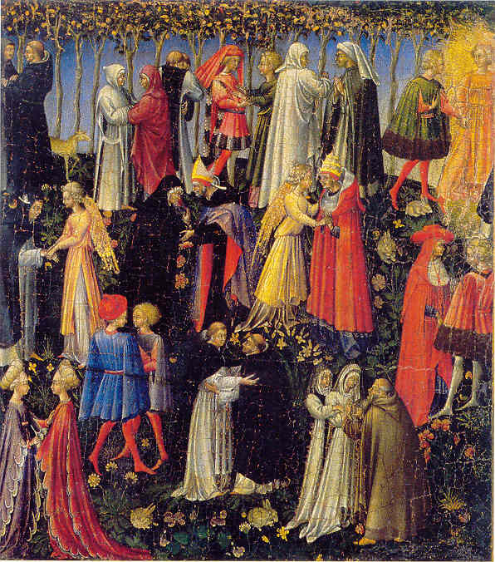
Paradise, by Giovanni di Paolo di Grazia, 15thC

This year,
Will we grow in the Spirit?

